Boleh Startup/Shutdown Guide – The Bluffer’s Guide
This does not override the detailed instructions in the SOP Annexes and Technical Instructions.

1. BOLEH is a truly unique historic vessel and, given her construction and age, it is you as Skipper that will ensure, through your diligence and attention to detail, that she remains in good condition for the future. It is incumbent on you to report all defects, address those within your competency and leave the her in as clean and ordered a condition as possible. Cleaning and maintenance materials are provided accordingly. We expect to have to replenish them regularly, please use them!

2. Take-over. The Skipper should check the following during take-over:

Emergency and Safety Equipment. Locations: On deck in cockpit and lockers, stowages adjacent to skipper mate’s berth, Emergency box between skipper and mate’s berths, hanging locker and cupboard opposite.
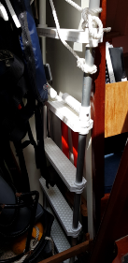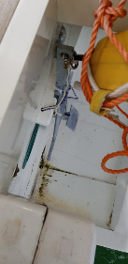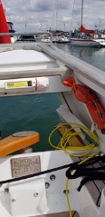
L. Hanging locker – spare boathook, MOB ladder, bolt croppers, emergency tiller, buckets.
M. Kedge anchor on transom, blue nylon anchor line attached.
R. Inflatable danbuoy, throw line, port horseshoe buoy
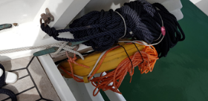 Stbd Horseshoe lifebelt and kedge anchor line.

Safety box between skipper and mate’s bunks. Check it is stowed in accordance with the plan in the technical section. Note grab bag for you to make up.
Side stowages aft cabin. Spares boxes. Lead line. Anchor ball, motoring cone. Fog horn. Cat C

Day to day First Aid kit is located under Port saloon seat. Use this and NOT the Cat C First Aid Kit for day to day cuts and grazes. Cat C FA Kit is in the emergency box and is to be used under instruction of a medical professional, either oboard or via radio.
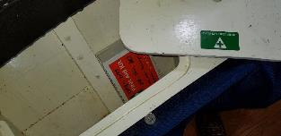
Day to day First Aid Kit – Use this routinely NOT Cat C FA kit in Green Valise.

Hanging locker. In use lifejackets (Childrens and additional adult jackets behind midships bunks). Buckets. Tender ancillaries. Emergency tiller. Boathook. EPIRB.
Locker opposite (under gas cooker) – safety harnesses.

On deck: life-raft, inflatable danbuoy, horseshoe life-belts, throwing line. In deck lockers, jackstays (if not rigged). Main anchor and chain secured, anchor windlass and handle/remote, kedge anchor (Stern).

Through Hull Fittings. Location and operation of seacocks, especially engine sea water inlet, exhaust manifold valve, heads in/outlet, log/depth impeller, emergency bungs in emergency locker.
    - Heads inlet and outlet (These MUST be kept CLOSED when not being used for flushing)
    - Generator sea water inlet open (quarter turn; in bilge forward of generator).
    - Generator exhaust valve open (1/4 turn in line with pipe in locker space to left of microwave).
    - Log impellor in place. Deck plate on Starboard side of saloon table.
    - Check no water in bilge. Fwd bilges – pump located in forward cabin bulkhead port side. For anchor locker and forward cabin bilges.
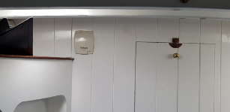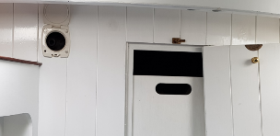
    - Switch over valve is in the anchor locker, to the port side of the access hatch. 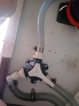

    - Pump handle is in the port side forward upper stowage.
    - Central/after bilges are serviced by the upper deck (cockpit) manual and electrical bilge pumps. Handles for the cockpit manual bilge pump is are stowed in the chartplotter cabinet on deck and for fwd bilge pump, the port side shelf in the forecastle berth.

Engines/Generator. (See also Generator Notes – Page 54 in the Technical Section)
Familirise yourself with the location and operation of engine controls in Starboard hatch in cockpit.
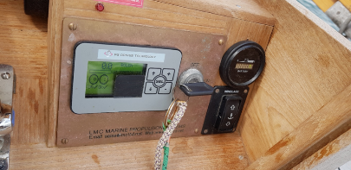

Round gauge is effectively your ready use fuel tank. LED level >5 is OK, drops from right to left. On #9 in picture. Switch on generator when it gets to level 5. In an emergency, can go down to 2 and batteries will recover. (Note manual windlass control below round gauge). Square gauge is level of power being set on port motor control lever. 60% is maximum for normal cruising ops. If levers are matched, starboard motor will be doing same as is displayed for the port motor.

Motor temperature gauges and overheat alarms are on the starboard side as you descend the companionway ladder, just above the EPIRB housing., in front of the hanging locker.
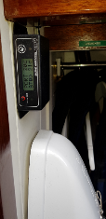 Engine Temperature Gauges (Black box above EPIRB housing)

Generator check – under saloon table: sea water filter, coolant header tank, engine oil dipstick/fillers, generator alternator belts; any tell-tale leakage in generator bilge; check for loose connections; generator fire extinguisher; fuel gauge, deck filler and key. Check no items are fouling the motors or shafts, motor drive belt tightness.
Fuel – Fwd end of generator box (saloon table). Check for water in sight glass of primary fuel filter.
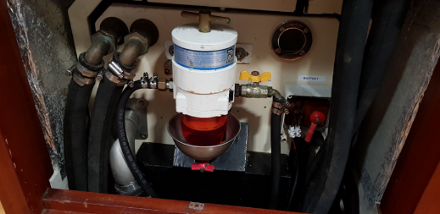
Red bleed valve under primary filter bowl to allow draining of any water present.
NOTE: Round fire extinguisher hose diaphragm to right of primary fuel filter.

Check fuel supply cocks open. Stbd side deck panel at bottom of companionway steps, fuel supply out and return valves open.
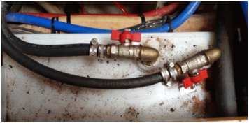
Cooling. Deck panel fwd of generator box – raw water seacock open?
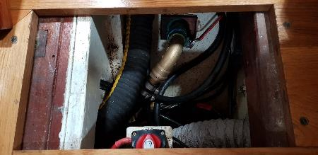
Generator raw water cooling seacock – Closed in picture.

Is starter battery still set to“on”?
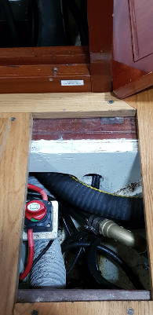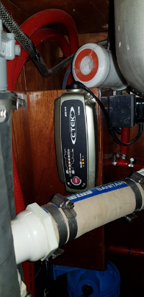
L. Generator Starter Battery Isolator set to “On”.
R. Generator starter battery charger under galley sink.

Exhaust – Port side bulkhead panel (aft of microwave) check that seacock is open. 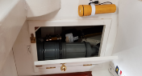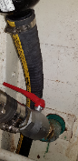

Routine Daily engine checks – “WOBBLE”. Lift up aft end of saloon table. Secure in up position with wire strop and snap shackle. Take off generator compartment wooden top. Taking care of wires attached to underside of central portion, Access stbd side of generator. Open up generator box. Oil, water filter, belts, bilges etc all accessible from here.

- Check fuel quantity is at 100% –main fuel tank gauge at chart table. Check 2 x emergency diesel cans in chain locker are filled.

- Check under the cabin sole at the foot of the companionway that the fuel flow and return valves are open by lifting the access panel adjacent to the WC door.
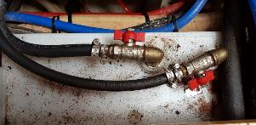
BOTH OPEN.

- Generator oil correct level on the dipstick (Remove generator box wooden top and starboard wooden side panel, and the sound shield starboard panel to access).
- Fresh water cooling tank correct level (access as previous step).
- Electrical bilge pump and hand bilge pumps are working.
- Generator manual available – In laptop bag.
- Record Generator working hours in Deck Log. Hours are displayed on generator start panel LCD screen when you press the green button.

Propulsion Check
Switch on main battery solenoid at the chart table switches (Rocker switch).
Insert key (kept in chart table) into ignition switch in stbd cockpit locker. Test ahead and astern propulsion on each shaft.
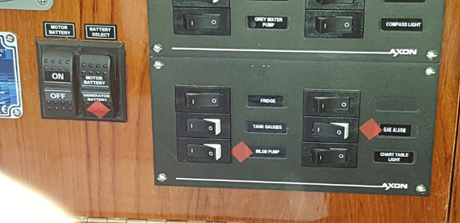
Left hand rocker switch – Motor Battery On/Off. Listen for solenoid activating when selecting “On”

Electrics:
Access nav station electrical panel. Turn on 12v systems as required.
Navigation aids in 2 locations:
Cockpit – Chartplotter/GPS
Navigation station – DSC/VHF radio, wind instruments, 12v electrical panel
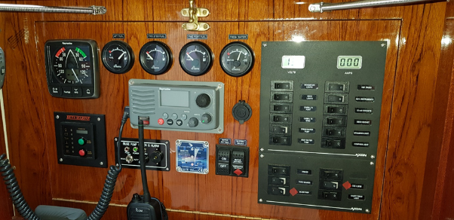
From Top Left: Wind indicator. Tank Gauges. 12v switch panel. Generator start/stop controls. DSC /VHF Radio (Centre). 12v Outlet (USB converter in tray below). Electric bilge pump control. Battery monitor. Engine motor battery and Generator start battery rocker switches.

Check GPS is set to WGS1984 datum and note HDOP (gives indication of GPS HDOP accuracy 1-2 OK, double figures – ignore it!). Set up plotter for displays you want. DO NOT change depth from reading below keel. You can split screen to provide chart and wind indications (Chart/data). Several Data screens set up including compass.
Check the readings of the Fuel and water tank gauges to ensure sufficient for planned programme and a contingency. Check electric bilge pump is operative. Return to “Automatic” mode.
Locate and check operation of battery master switches, link switch under chart table. Generator battery switch (in bilge area fwd of generator).
Windlass trip Starboard bulkhead, forward of the galley.
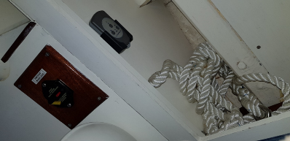
Windlass trip switch, windlass remote control, anchor snubber.

Operation of shore power and cables/adaptors/shoreside meter (if fitted). The inboard shorepower connection is located on the transom and is fragile. The cable connector is inserted into the boat connector and rotated 20 degrees to lock it in place. Then the grey plastic ring on the cable connector is screwed onto the metal thread on the boat connector. Remember this when you come to take it off!!! See picture over…..
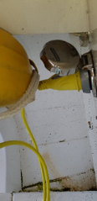

Jump leads.
Check the meaning/location of switches for all services for navigation and domestics; log/echo sounder on main 12v switchboard.
Check navigation lights are working.

Battery check
Switch on the main battery solenoid at the chart table. Check red light is on at the box sited to the left of the main chargers underneath chart table. See picture below with chargers. If light is not lit and you have not heard solenoid activate (Loud clunk or click), lift up the rear most deck plate behind the companionway steps and you can operate the relay manually by pulling up the round black knob in the middle of the aft grey box.
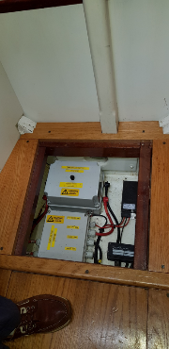
Note: Foot/shoe not always present.

Switch on motor control panel in cockpit (Stbd side) and confirm main batteries are fully charged. If the main battery charge is not full, run the generator to re-charge before departing.
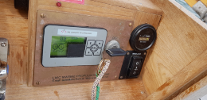

Turn off the generator battery minder on the AC panel, put the battery select rocker switch to generator and check the battery is charged/charging using the battery state LED panel at the chart table.
Change to main battery 12V DC supply using the battery selector rocker switch.

Charging Check
Once you are ready to depart/have departed ensure that you have changed the charging switch (Fwd bulkhead under chart table) from “shore power” to “generator” – simple changeover switch.
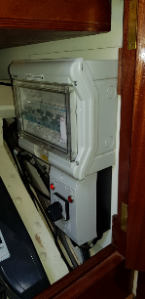
Shore power/generator changeover switch with 240v circuit breakers above (E.G. 12v battery charger, microwave over, 240v outlets etc)

Once the generator is started and settled, ensure that you have turned on the 2 chargers (facing you under chart table when you open doors – grey boxes, simple rotating on/off switch).
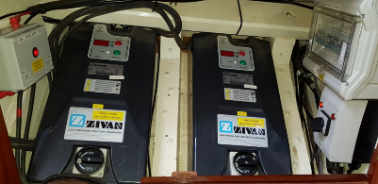
2 x 72v chargers. Note red light is on, on the box to left of chargers.
If the chargers are “dead”, no lights, numbers in panels etc, check main 240v circuit breakers at aft end of the generator box/saloon table:

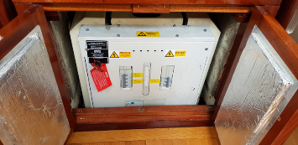
Breakers in “live” positions. NOTE: Generator box Auto Fire Extinguisher manual override “T” handle to left of breakers, with red tally attached.

Galley Check
To use 240v sockets for cooking/drinks and the microwave, you need to run the generator.
Check that the circuit breakers (Fwd bulkhead under the chart table) are set to live for the equipment you wish to use.

Gas. Location and operation of gas system, valves and switches. Bottles in counter on stern and isolation valves port side aft below decks.

Fresh Water. Location of fresh water tank. Port side aft of chart table. Switch for water pressure pump on 12v switch panel. Deck filler point is in port side narrow deck, just fwd of port sheet winch. A metal filler cap key/shackle key hangs on lanyard to left of chart table with hand bearing compass.

The hot water calorifier is situated under the galley sink area. 240v circuit breaker is on the breaker panel below the chart table. It will heat the water when on generator or shore power.
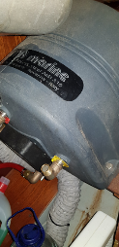

Grey Water Waste. Sinks are set to drain into grey water tank, as is the heads sole. There is an electric pump switch on the 12v panel to empty the tank. Capacity 53 ltrs. Only pump out at sea when >3Nm from the coast. The grey water through hull fitting is just aft of the heads.

Black Water Waste.
Black water holding tank and heads in/out valves are situated under deck plate just in front of and aft of heads door. Do not operate pump before opening overboard discharge seacock.

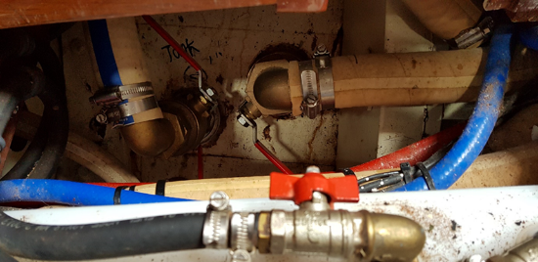
(Diesel pipe in foreground) Heads In/Out seacocks and Grey water overboard discharge.

The default settings for black water waste is for overboard discharge. Note that IMO Marpol regulations prohibit the discharge of black water waste within 3 miles of land. If berthed in an area of low tidal flow or if locked into a marina and toilet facilities are not immediately to hand, it is recommended that the black water tank be used. Pump out ashore at an approved facility is always preferable to discharge at sea.

Below the Heads sink is a gate valve that cycles between overboard discharge (default) and black water tank. The pipes are marked clearly.

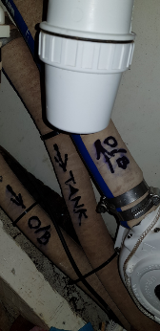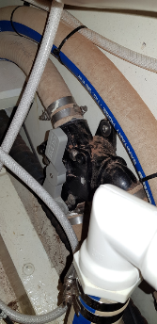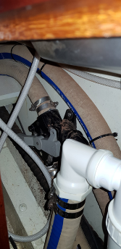

Pipe Markings Overboard To Tank

In this same area under the heads sink there is also a hand pump which is for discharging the black water tank either overboard or into a pump out facility via a deck connection on the Starboard side.

If you are trying to pump out overboard and the pump handle won’t move or is very stiff, you are trying to pump out through the deck fitting and need to change the Second Y valve that is under a removable deck plate on the port side, just aft of the chart table. See pictures below. Overboard

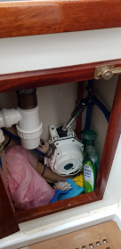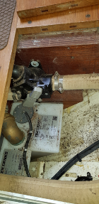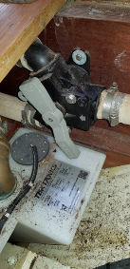
Pump out handpump Overboard Through deck fitting

Black Water Tank pump out controls. Y Valve below deck plate to port/aft of chart table.

Stowages. Check stowage plan and inventory including boatswain chair, lead line, First Aid box, courtesy flags(chart table if required) windlass remote(Stbd fwd bunk), preventer (fixed under boom), boat hook, tools and spares, Bosun’s box , binoculars; on bucket/sponge, spare water and fuel containers, spare oil, deck scrub, boat hook, manual bilge pump/handle, anchor ball and motoring cone; dinghy and pump, if carried.
Cockpit/Deck Preps
Rigging. Visual check of standing rigging, security of fastenings, life-lines and stanchions, jackstays, security of stern/pulpit. Hoist radar reflector on port side signal halyards (with quick release shackles).
Place emergency knives, sheet winch handles and genoa halyard winch handles in stowages.
Access port and stbd lockers for engine controls and chart plotter.
Stowages just fwd of these contain spare sail ties and jackstays.
Sail cover off, main halyard checked secured to mainsail.
Untie tiller, check free and full movement of rudder.
With engines available for use if required, change from bowlines to slip lines in readiness to depart.
Before departing (!!) detach shore power cable from jetty, THEN UNSCREW the end on the transom and stow below. An extension is provided if required.
Sails. Check location/operation of sails, controls and reefing system; including storm sails.

Depth Calibration. Using lead line, check that depth is still calibrated to read depth below the keel not waterline or transducer. (Depth readout on electronic nav plotter).

Documents. Identify the ships log, defects book, ships papers and insurance certificates. Ensure chart outfit, tidal stream atlases, almanac and pilot books are present. Ships documents in laptop back stbd aft bunk. Rest in chart table or bookcase.

Defects. Check that all reported defects have been resolved or are within safe limits.

Levels. Check fuel, water and gas levels.

Navigational equipment check. Have you done your legally compliant passage plan? Have you started the log – in pen NOT pencil – it’s a legal document.
Have you plotted your planned passage onto charts?
Have you entered your passage into the chart plotter?
Have you completed your pilotage plan to get out Portsmouth?
Have you obtained an up to date weather forecast?
Charts required are aboard (in chart table). GPS Datum set to WGS84.
Check that echo sounder is reading from bottom of keel. Lead line port side aft stowage.
Current almanac, tidal atlases and necessary pilots, are checked and prepared.
Steering compass – Clipped in place in cockpit with box lid removed and stowed. Note the compass, when not in use, is stowed on starboard shelf in aft cabin
Fog Horn.
Radar Reflector (on port flag halyard) when required.
Barometer – check reading.

Hand-back. The Skipper should ensure the yacht is handed back in good order and any issues reported. Cleaning should be thorough.

Topping Up. On return to home port, refill fuel and water, identify and hand over empty gas bottles. Empty gas bottles should normally be replaced by the charterer.
Berthing. Ensure bow, stern and spring dock lines are secured correctly, fenders fixed and adjusted correctly. Use one line for one purpose only. See SOPs if unsure what is required.
Defects. Record and report any defects including those resolved by the crew, using the defects book.
Damage and Losses. Provide reports on any suspected/damage or losses, especially concerning groundings or fouling of propeller or shaft. NO SECRETS PLEASE!
Sails. Reefs shaken out, flake main on boom and sail cover on securely. Dry and fold all foresails, check and report any damage with diagrams where necessary. Do not stow wet sails in sail bags.
Chart Table. Check that the Ship’s and Generator logs have been completed for the cruise and logbook closed. All paper charts and tidal atlases are to be cleaned off, charts placed in their folios in the correct order and chart table tidied.

Seacocks are turned off:
  - Heads inlet and outlet valves.
  - Generator Sea water inlet and exhaust valves.
  - Holding tank pump outlet valve.

Rig shore power if appropriate (LED is on) and selected on charging input selector.

All electric switches turned off except: Generator start battery isolator switch on. Generator battery charger breaker on. Bilge pump set to auto. Gas alarm on. These are indicated by red spots on the switches.
Gas system isolated throughout including at the bottle.
All unused foodstuffs and rubbish are taken ashore and disposed of appropriately
Stowage. Gear stowed as per STOWAGE plan
Mattresses and cushions are raised to allow them to air. Forecastle stowage lids off to air. Do not leave wet cordage on mattresses or dry cordage. Leave it in the forecastle where it can air dry.
On Deck:
Tiller lashed securely.
Chartplotter removed and stowed on Mate’s bunk (port side aft). Charts, tidal atlases etc cleaned off and stowed in correct order.
Burgee and Ensign are taken down and stowed.
Steering Compass box unshipped and stowed in aft cabin.
Washdown. Alongside, wash decks and fittings down with fresh water.
Hatch Covers. Fit canvas hatch and skylight covers

Bilges dried, limber holes checked and clear. Bilge pump set to auto. Forecastle, forward and main bilges pumped out.

Bulkheads and deckheads, flat surfaces. All should be wiped down with anti-bacterial spray to deter the growth of black mould. Particular attention is required in the heads and in the area around the skipper and mate’s berths, underneath the cockpit which is prone to condensation and black mould growth.

Woodwork. All woodwork polished.

Galley. Galley area cleaned thoroughly. Microwave cleaned of food debris and dried. Cold box washed, dried, turned off and left open to air. Gas hob cleaned. Sink cleaned. Work surfaces cleaned.

Internal decks. Should be swept clean.

Lifejackets and harnesses checked for damage and counted. Any activated? If yes, report. Hang up used harnesses and lifejackets in the wet locker.

Paperwork. Complete Skipper’s report. Either provide to Bosun / Yacht Manager or scan and send to George Middleton: rewe_farm@hotmail.co.uk.

Security. Fore hatches (screw down fittings), main hatch (padlock), navigation display locker (pin) and motor control locker (pin) are secured.

Formal handback. Where possible conduct face to face handback to the Bosun/Yacht Manager/trustee representative.

