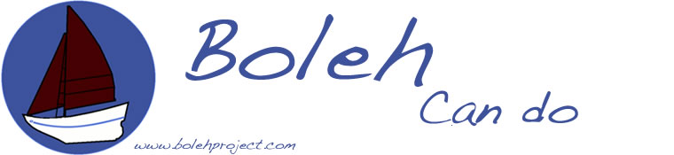

The Boleh Trust (Registered Charity 1175954)

DAY SAIL BOOKING FORM

EVENT DETAILS
Event name | MIDDLETON SAIL
Venue | Haslar Marina
Date | Saturday 15 September 2018
Event Co-ordinator | Henry Middleton
Boleh Trust Skipper  Event details | Jeff Leigh-Jones (Halcyon Yachts)  Emily Chambers Mate  Day Sail

PARTICIPANT CONTACT DETAILS
Name
Address
Contact no.
Email address:
If you are under 18, your parent or guardian must complete and sign the Parental/Guardian Agreement Form at page 4.

ABOUT YOU
Do you have any previous boating experience or qualifications?
If yes, please give brief details.
Can you swim 25 metres?
In the interests of your safety do you have any medical conditions or physical or mental impairments that the organiser needs to be aware of that may affect your ability to take part in the Event? | Yes/ No  If you answer yes please provide further details in the Medical Information and Impairments section of this form at page 5.
Name and Telephone number of emergency contact.

BOOKING TERMS

- RISK STATEMENT
It must be recognised that sailing is by its nature an unpredictable sport and therefore inherently involves an element of risk. By taking part in the Event, you agree and acknowledge that:
- You are aware of the inherent element of risk involved in the sport and you accept responsibility exposing yourself to such inherent risk whilst taking part in the Event;
- You will comply at all times with the instructions of the Skipper particularly with regard to handling of boats, wearing of buoyancy aids and the wearing of suitable clothing for the conditions;
- You accept responsibility for any injury, damage or loss to the extent caused by your own negligence;
- You will not participate in the Event if your ability to participate is impaired by alcohol, drugs or if you are otherwise unfit to participate;
- You will inform the Skipper if there have been any changes to the information provided on this form at the time of the Event.
- You are aware of any specific risks drawn to your attention by the Skipper or Event Co-ordinator.

- CANCELLATION
You understand that the Skipper may cancel or postpone the Event at any stage in the event of bad weather, equipment failure or otherwise.

- MISCONDUCT
You understand that the Skipper may exclude anyone from a particular session and evict anyone from the premises who refuses to comply with these Booking Terms or who misconducts themselves in any way or who causes damage or annoyance to other persons.

- DATA PROTECTION
The Boleh Trust has a Data Privacy Policy which can be obtained from the Boleh Trust Office. Your data will be stored and used in accordance with that policy.

The information you provide in this form will be used to facilitate your participation in the Event and to contact you. The Boleh Trust would also like to include your contact details on a mailing list so as to make you aware of membership opportunities and future events.
If you would like to be included on this mailing list please tick here

If you wish to withdraw your agreement at any time, please contact the Boleh Trust.

- USE OF YOUR IMAGE
The Boleh Trust may arrange for images or videos to be taken at the Event and published on the Event or our website or social media channels to promote the Event or the work of the Boleh Trust.

If you agree to the use of images of you being used for this purpose, please tick here.

If you are taking part in the Event as a family, your family members, aged 18 and over, should indicate their agreement to the use of their image separately below.
Parental agreement for images of participants aged under 18 is included in the Parental/Guardian Agreement Form at page 4.

Family member ………………………………..

Family member ………………………………..

Family member ………………………………..

If you later wish to withdraw your agreement, please contact the Boleh Trust. Please be aware that if you later decide to withdraw your agreement it will not be possible to remove your image from any printed material in circulation, or until the next edition or print of the item containing your image is released.

By agreeing to your images being used, you agree to assign any copyright or any other right of ownership of these images to the Organiser.

AGREEMENT
I confirm that I have read and fully understand the above Booking Terms and agree to comply with them.

Signed………………… (The Participant)

Date……………………….…………….

MEDICAL INFORMATION AND IMPAIRMENTS
If you declared that you have a medical condition or physical or mental impairment that the organiser needs to be aware of because it may affect your ability to take part in the Event please provide details below.

SPECIAL CATEGORY DATA
I confirm that I have given the Boleh Trust the medical information listed on this page (if any) for the purposes of my participation in the Event. I understand that this information will only be used for that purpose and will be retained for as long as necessary to comply with the Boleh Trust’s legal obligations.

I agree/ I do not agree (Please circle)

The Boleh Trust, The Old Shop, Enford, Pewsey, Wiltshire SN9 6AR
May 2018

